**IFT 466 Advanced Computer Networks**

**Lab 11  
EIGRP – Advanced Topology**

After you complete each step, put a ‘√’ or ‘x’ in the completed box

1. Setup up the following topology on Packet Tracer

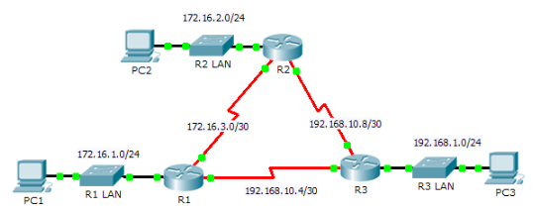

✓****

1. Configure the PCs and Routers with the following configurations

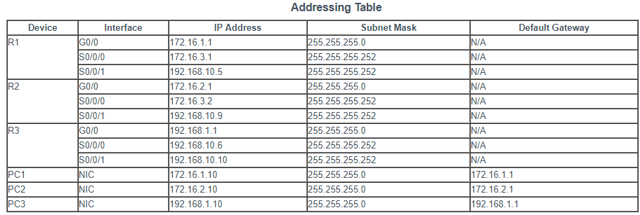

 ✓

1. Can PC1 ping PC2 or PC3

✓

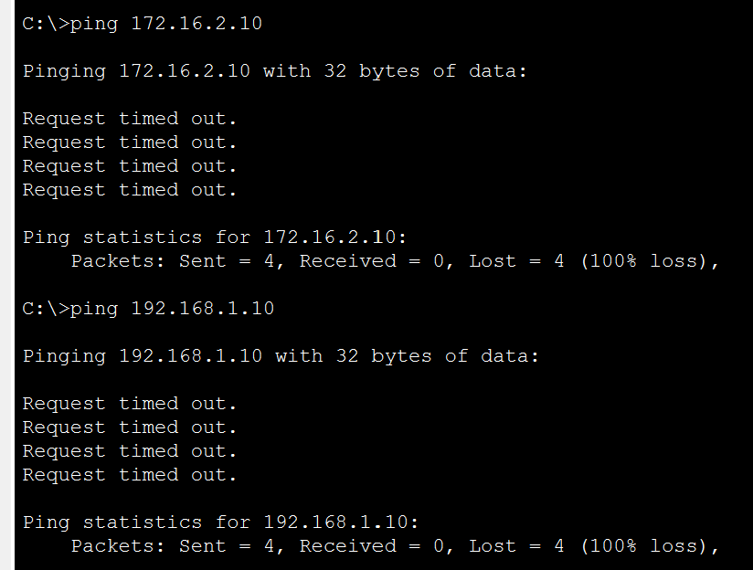

Explain your answer

The ping did not work since the connection between the routers is not established yet. We should create a routing process and add neighbors so the routers know each other.

1. Enable the EIGRP routing process on each router using AS number 1

Advertise directly connected networks via the network command

 ✓

1. Configure the LAN interfaces to not advertise EIGRP updates i.e. passive interface command



✓

1. Disable automatic summarization.  
     
   This topology contains discontiguous networks. Therefore, disable automatic summarization on each router.

R1(config-router)# no auto-summary

Note: Prior to IOS 15 auto-summary had to be manually disabled.



✓

1. Verify EIGRP Routing

Use the show ip route to see that the routers have learned the other subnets



✓

1. Verify end-to-end connectivity. PC1, PC2 and PC3 should now be able to ping each other.

If not, troubleshoot your EIGRP configurations.



✓

